Secure File Sharing Using AES Encryption
Adwaith S | Am.en.u4cse22301
Kavya P | Am.en.u4cse22326
Bharadwaj Kesav P | Am.en.u4cse22316
Adithya Krishna J | Am.en.u4cse22311

I. Introduction

Brief Overview
This project focuses on implementing a secure file-sharing system using AES (Advanced Encryption Standard) encryption. The system ensures confidentiality and secure data transfer, allowing users to upload, encrypt, download, and decrypt files through a web-based interface. Authentication mechanisms add an extra layer of security to restrict access to authorized users only.

Objective
The primary objective is to create a user-friendly application for secure file sharing. This system ensures:
- Confidentiality: Encrypting files using AES.
- Secure access: Using password hashing for authentication.
- Ease of use: A web interface to facilitate secure file operations.

II. Implementation

Tools and Software Used
- Programming Language: Python
- Framework: Flask (for building the web application)
- Encryption Library: PyCryptodome (for AES encryption)
- Authentication Library: bcrypt (for password hashing)
- Database: Mock in-memory dictionary (for user credentials)
- Environment: Localhost (for testing the application)
- IDE: Any Python-compatible IDE (e.g., PyCharm, VS Code)

Description of Steps Taken

1. Setting Up the Project Environment
- Installed necessary libraries: Flask, PyCryptodome, and bcrypt.
- Configured a basic Flask application structure with routes for uploading, downloading, and user login.

2. Implementing Encryption and Decryption
- Encryption: Used AES encryption in CBC mode to securely encrypt uploaded files.
- Decryption: Implemented a decryption mechanism to retrieve original files using the provided key.

3. User Authentication
- Passwords were hashed using bcrypt to ensure security.
- Authentication logic verifies user credentials before granting access to file operations.

4. Building the Web Interface
- Created templates (home.html, upload.html, download.html, and login.html) to provide a seamless user experience.
- Forms allow users to upload files, download decrypted files, and log in securely.

5. Handling Files Securely
- Uploaded files are saved in a designated folder (static).
- Encrypted files are stored with an .enc extension.
- Decrypted files are generated dynamically for download and not permanently stored.

6. Error Handling
- Ensured robust error handling for invalid keys, unsupported file formats, and other exceptions.

Screenshots and Diagrams
- Login Page
  - User authentication interface.
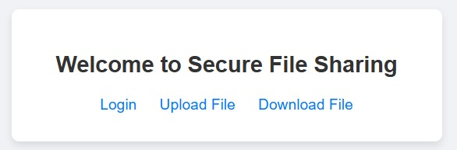
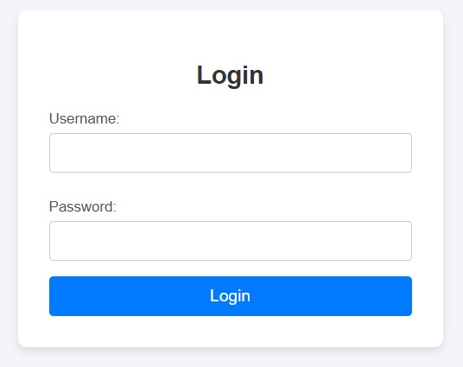
- Upload Page
  - Form to upload and encrypt files.
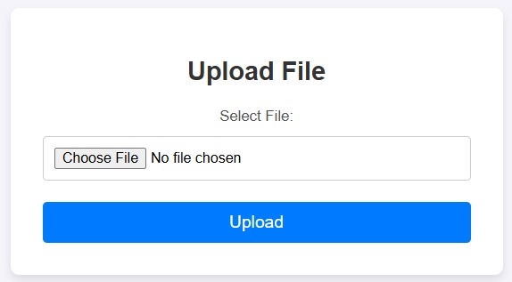
- Download Page
  - Form to upload encrypted files and provide the key for decryption.
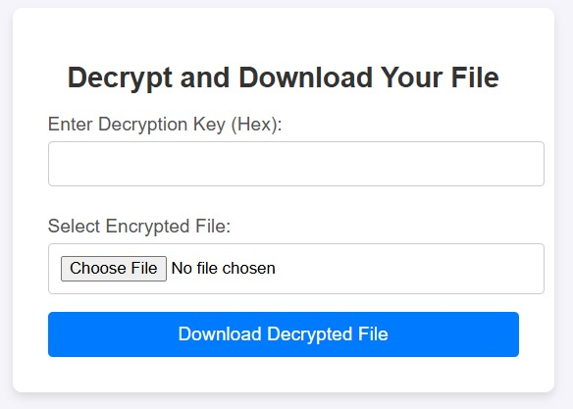
- Diagram: Flowchart of the secure file-sharing process.
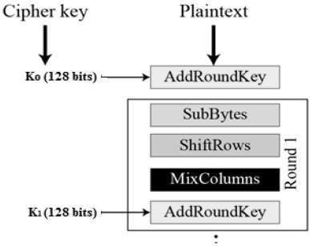

III. Results

Output or Results
- Successful Encryption
  - Uploaded files are encrypted using a randomly generated AES key.
  - Users receive a hexadecimal key for decrypting their files.
- Successful Decryption
  - Users can decrypt files by providing the correct key.
  - The original file is returned for download.
- Secure Authentication
  - Only authenticated users can access file upload and download functionalities.

Observations
- The AES encryption ensures robust security for file contents.
- The user interface is intuitive and easy to navigate.
- Proper error handling prevents misuse and enhances user experience.

IV. Conclusion
The project successfully demonstrates a secure file-sharing system using AES encryption and Flask. By integrating strong encryption and secure authentication, the system achieves its objective of protecting sensitive files during transfer and storage. Future improvements could include:
- Integration with a database for storing user data.
- Support for role-based access control.
- Implementation of a file expiration mechanism for enhanced security.
The system provides a strong foundation for secure file-sharing applications in real-world scenarios.

